Name : kanyonga chouella

ID: 658278

**QUIZ1:**

Here are the pictures of my webpage :

1.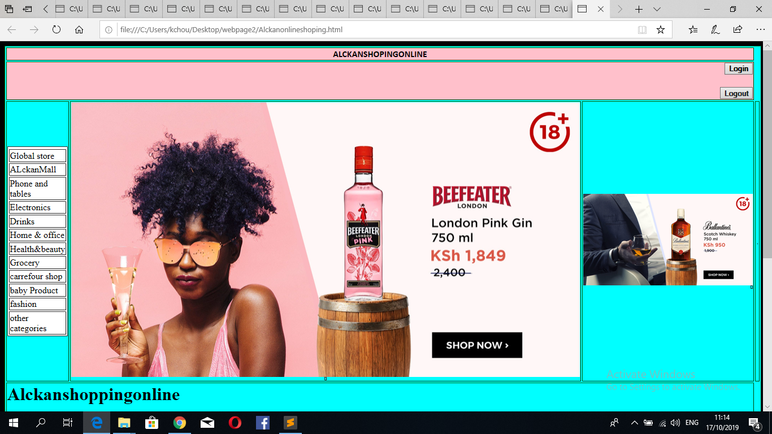

2.

